1. **Total Paint Materials Cost over the Months**

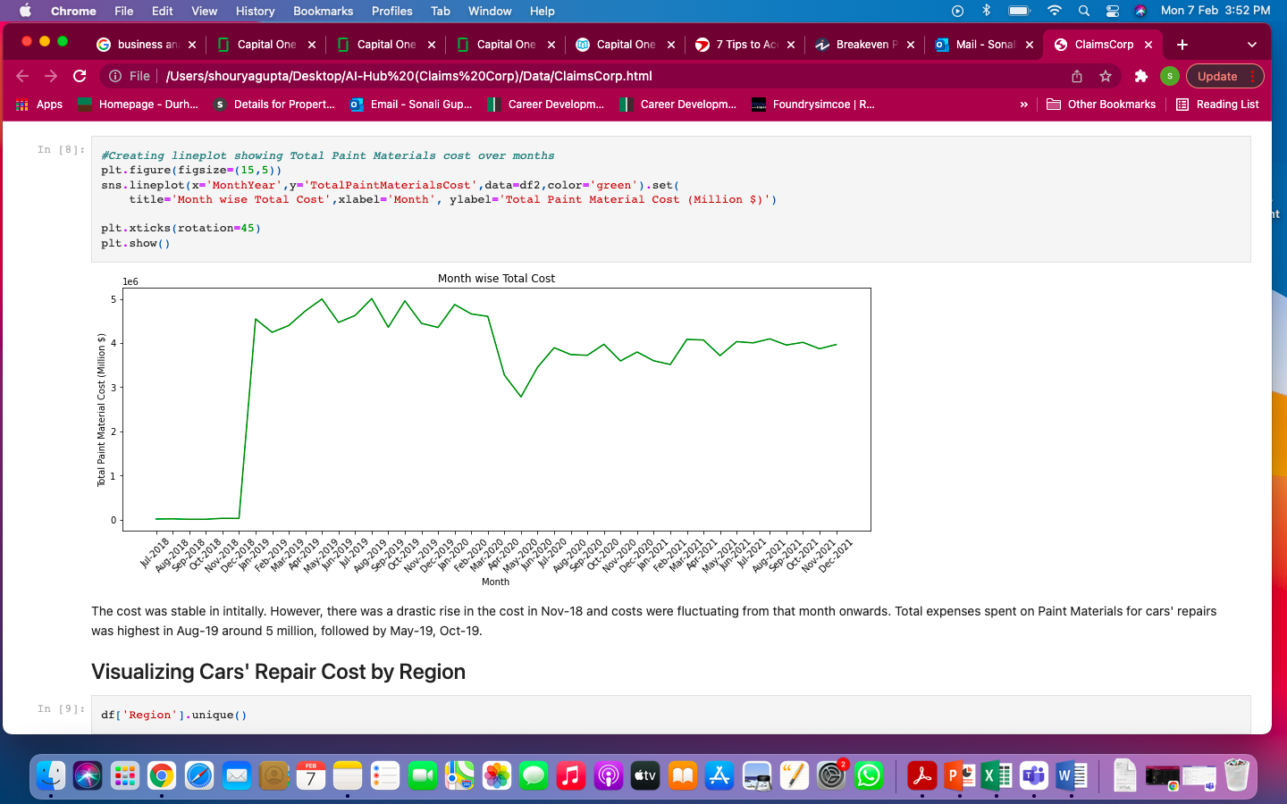

The cost was stable in initially. However, there was a drastic rise in the cost in Nov-18 and costs were fluctuating from that month onwards. Total expenses spent on Paint Materials for cars' repairs was highest in Aug-19 around 5 million, followed by May-19, Oct-19.

1. **Total Paint Materials Cost by Regions**

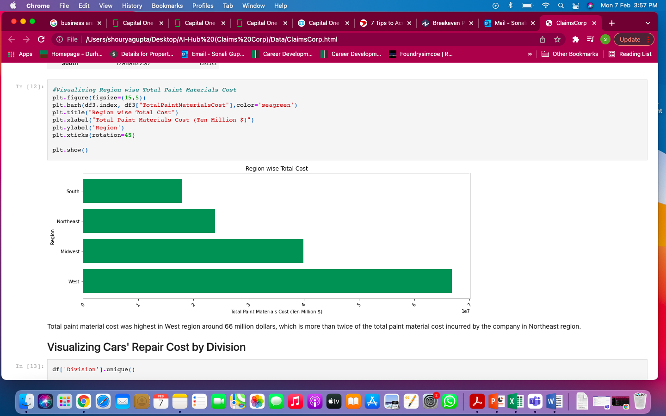

Total paint material cost was highest in West region around 66 million dollars, which is more than twice of the total paint material cost incurred by the company in Northeast region.

1. **Total and Average Paint Materials Cost by Divisions**

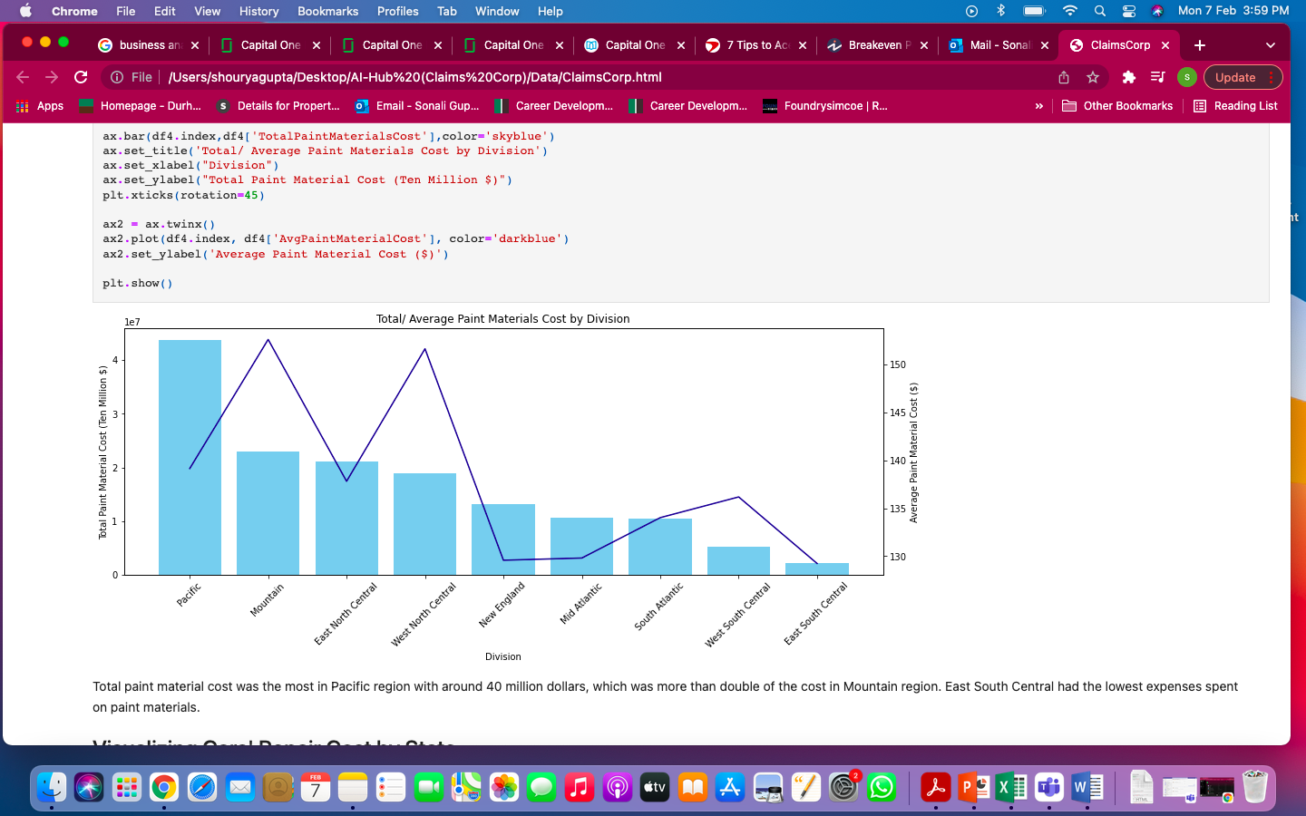

Total paint material cost was the most in Pacific region with around 40 million dollars, which was more than double of the cost in Mountain region. East South Central had the lowest expenses spent on paint materials. Average cost was highest in Mountain region of approx. 155 dollars and lowest in East South Central.

1. **Total Paint Materials Cost by States**

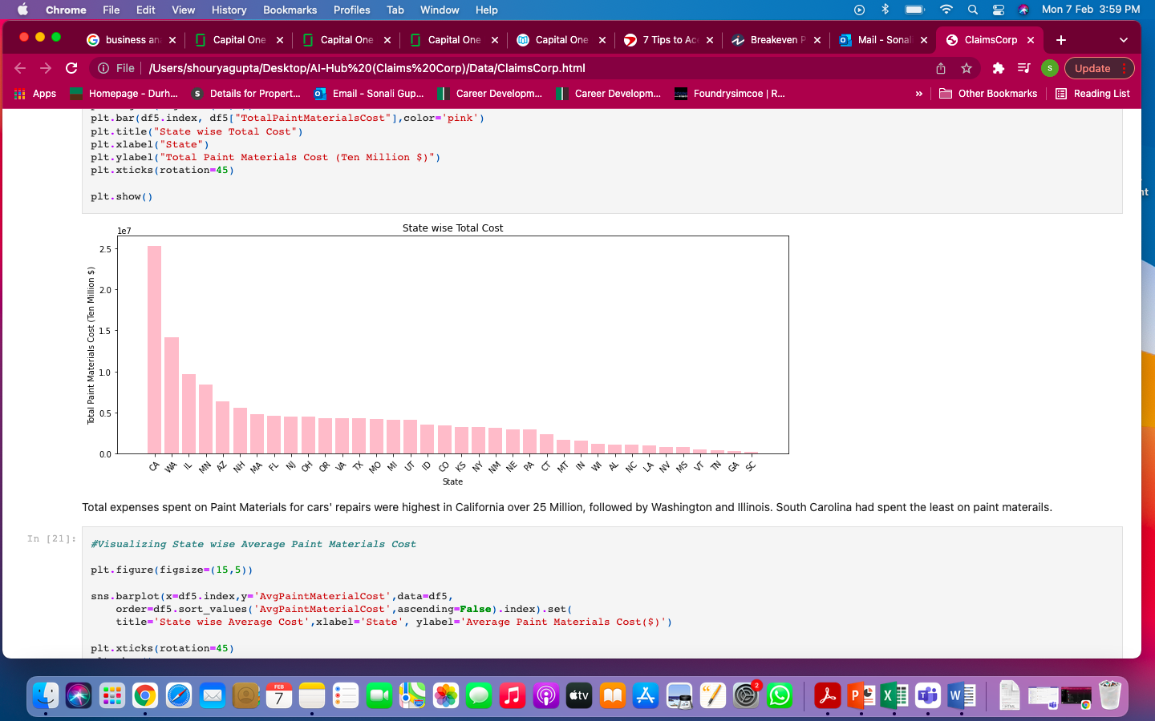

Total expenses spent on Paint Materials for cars' repairs were highest in California over 25 Million, followed by Washington and Illinois. South Carolina had spent the least on paint materials.

1. **Average Paint Materials Cost by States**

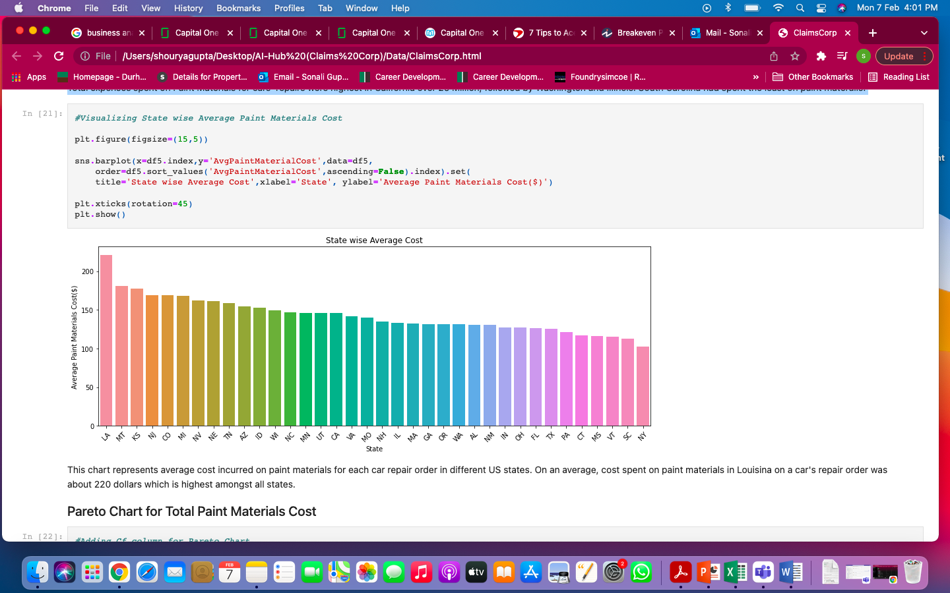

This chart represents average cost incurred on paint materials for each car repair order in different US states. On an average, cost spent on paint materials in Louisiana on a car's repair order was about 220 dollars which is highest amongst all states.

1. **Pareto Chart for Total Paint Materials Cost and States**

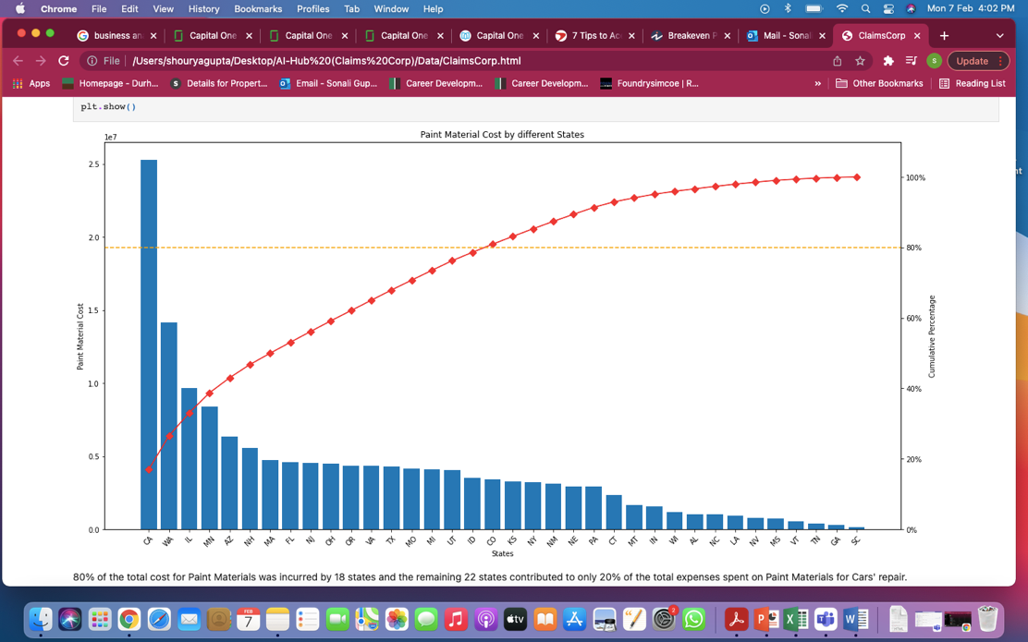

80% of the total cost for Paint Materials was incurred by 18 states and the remaining 22 states contributed to only 20% of the total expenses spent on Paint Materials for Cars' repair.